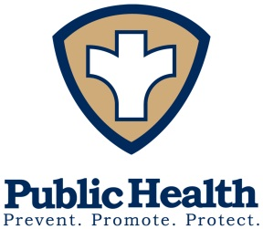
Harford County Health Department
“Healthy People in a Healthy Environment”

POSITION VACANCY ANNOUNCEMENT
Job title | Nutritionist I
Position Summary | The Nutritionist I will conduct health and nutrition assessments, provide nutrition care, counseling, and follow up on high-risk referrals. In addition, this position will plan, develop, and implement nutrition plans, maintain representation at outreach events, and submit monthly reports.  Refer to State of Maryland Job Aps website for more information.
Required Qualifications/Licensures | Education: Determined by the Maryland State Board of Dietetic Practice under the licensing requirements for Nutritionists and Dietitians.  Experience: One year of experience providing professional nutrition or dietetic services.  Note: A Master’s Degree from an accredited college or university in Public Health, Community Health or Nutrition may be substituted for the required experience.  Licensure  1. Candidates for positions in this classification must possess a current license as a Dietitian/Nutritionist from the Maryland State Board of Dietetic Practice, 4201 Patterson Avenue, Baltimore, Maryland 21215 prior to permanent appointment.  2. Employees in the classification may be assigned duties which require the operation of a motor vehicle. Employees assigned such duties will be required to possess a motor vehicle operator's license valid in the State of Maryland.
Job type | Merit position, Full time with benefits
Position Location | Harford County Health Department, WIC Program
Closing Date | Refer to State Job Aps System
Salary | Grade 14/Base
Application Procedure | All applicants must apply through the State of Maryland Job Aps System (link below):
 | http://dbm.maryland.gov/jobseekers/Pages/JobSearch.aspx

Harford County Health Department is an Equal Opportunity Employer.

